Project Report: Float Fall Bouncing

front page

certificate

declaration

acknowledgment

Abstract

Contents

Introduction

Flow Diagram

Algorithm

Source Code

Output Cases

Result And Discussions

Conclusion

Reference

Appendice

Table of Contents

Introduction

Framework and Tools Used

Simulation Logic and Features

Techniques Used

Advantages and Disadvantages

Definitions of Functions Used and Classes

Summary

Conclusion

Further Scope for Improvement

1. Introduction

Float Fall Bouncing is a physics simulator developed to demonstrate the effects of gravity in different mediums and environments. The project aims to provide users with an interactive experience of controlling balls and observing their motion on various surfaces. By simulating realistic physics and gravity interactions, Float Fall Bouncing serves as an educational tool and a source of entertainment for users interested in physics and simulations.

2. Framework and Tools Used

The physics simulation project utilizes the following frameworks and tools:

- Pygame: A Python library that provides functionalities for graphics rendering, user input handling, and game logic, which are essential for building a physics simulator.

- Python: The programming language used for developing the simulation.

- Integrated Development Environment (IDE): Visual Studio Code and Python IDLE for coding and testing the simulation.

- Graphics Editing Software: Tools like Adobe Photoshop, Canva, and 3D Paint for creating or editing the simulation's visual elements.

3. Simulation Logic and Features

Float Fall Bouncing's simulation logic revolves around the fundamental principles of physics, particularly the force of gravity and object motion. The simulator enables users to control multiple balls using keyboard inputs, allowing them to apply forces and observe the resulting motion. The balls interact with the ground, exhibiting realistic bouncing behavior based on collision detection and physics calculations.

Key features of Float Fall Bouncing include:

Ball control: Users can manipulate the position, velocity, and direction of the balls using keyboard inputs.

Bouncing physics: Balls bounce off the ground with realistic physics, taking into account factors such as elasticity and momentum.

Environment switching: Users can switch between different environments, such as "ground," "water," or "moon," each with its own gravity settings.

Velocity vectors: Float Fall Bouncing displays velocity vectors for each ball, providing visual feedback on their speed and direction.

Interactive mode: Users can interact with the simulation by dragging, dropping, and adding balls in interactive mode.

4. Techniques Used

Float Fall Bouncing employs various programming techniques and concepts to create an immersive simulation experience. Some of the techniques used include:

Event-driven programming: The simulation responds to user inputs and events, such as keyboard presses and mouse interactions.

Physics calculations: The simulator utilizes physics equations and calculations to determine the motion of the balls, considering factors like gravity, forces, and collisions.

Graphic rendering: Pygame's rendering capabilities are utilized to display the balls, environments, velocity vectors, and other visual elements.

Object-oriented programming: The project follows an object-oriented approach, using classes and objects to represent entities like balls and environments.

5. Advantages and Disadvantages

Float Fall Bouncing offers several advantages as a physics simulator:

Interactive learning: Users can experiment with different scenarios and observe the effects of gravity in real-time, enhancing their understanding of physics concepts.

Engaging visualization: The graphical representation and visual feedback make the simulation engaging and intuitive to use.

Customizability: The ability to switch environments, control multiple balls, and adjust density provides flexibility and customization options.

However, there are a few limitations and disadvantages:

Simplified physics model: Float Fall Bouncing employs simplified physics calculations and may not capture all the complexities of real-world physics.

Limited scope: The simulator focuses primarily on gravity and object motion, and does not incorporate other forces or advanced physics concepts.

6. Description of files

Float Fall Bouncing utilizes several functions and classes to implement its functionality. Here are some descriptions of the files containing them:

main.py: The main script that serves as the entry point for the project and handles the game loop.

menu.py: Contains functions related to the user interface, including menu options, environment switching, and ball type.

loadScreen.py: Provides functions for loading screens and displaying the loading animation when the program begins.

vectors.py: Implements functions to calculate and display velocity vectors for the balls.

end.py: Provides the functionality to show the exit menu.

buttons.py: Stores the Button class for creating and controlling the behavior of buttons.

window.py: Stores the Window class that provides functions for window size.

7. Summary

Float Fall Bouncing is a physics simulator that showcases the behavior of bouncing balls in different environments. Users can control the movement, add or remove balls, and observe their motion under the influence of gravity. The project utilizes the Pygame library for graphics rendering and user interaction, providing an immersive and interactive experience.

8. Conclusion

Developing Float Fall Bouncing has been a rewarding experience, as it successfully demonstrates the effects of gravity and object motion in an engaging manner. The project achieves its objective of providing an educational and entertaining physics simulator, offering users the opportunity to explore and understand fundamental physics principles through interactive simulations.

9. Further Scope for Improvement

To further enhance the physics simulation project, the following improvements can be considered:

- Advanced Physics Models: Implementing more sophisticated physics models, such as fluid dynamics or rigid body dynamics, to simulate a wider range of physical phenomena.

- Real-Time Data Visualization: Incorporating real-time data visualization techniques to display and analyze simulation data, allowing users to observe and interpret the results more effectively.

- Interactive Controls: Adding interactive controls that enable users to manipulate simulation parameters in real-time, offering a more engaging and interactive experience.

- Multiple Simulations: Allowing users to create and compare multiple simulations simultaneously, facilitating comparative analysis and exploration of different scenarios.

- Export and Sharing: Providing options to export simulation data or share simulations with others, enabling collaboration and educational purposes.

By implementing these improvements, the physics simulation project can become more comprehensive, visually appealing, and educational, offering a broader range of simulations and interactive features.

Overall, the physics simulation project demonstrates the potential of Pygame for creating interactive and visually engaging simulations. It serves as a foundation for further exploration and development in the field of physics simulations using Python.

Code Outline

1. `main.py`:

```

# Import required libraries

# ...

# Initialize Pygame

# ...

# Set up the game screen

# ...

# Initialize game variables

# ...

# Load game assets

# ...

# Define game functions

# ...

# Function to handle program execution

# ...

# Start program execution

# ...

```

2. `menu.py`:

```

# Import required libraries

# ...

# Set up the menu screen

# ...

# Load menu graphics

# ...

# Initialize menu variables

# ...

# Loop for menu interaction

# ...

# Function to handle menu display

# ...

# Handle user input

# ...

# Update menu display

# ...

# Check for user input events

# ...

# Return selected menu option

# ...

```

3. `loadScreen.py`:

```

# Import required libraries

# ...

# Define loading screen function

# ...

# Load loading screen graphics

# ...

# Display loading animation

# ...

# Return to main program

# ...

```

4. `vectors.py`:

```

# Import required libraries

# ...

# Define function to display velocity vectors

# ...

# Calculate and display velocity vectors for balls

# ...

# Draw velocity vectors on the screen

# ...

```

5. `window.py`:

```

# Import required libraries

# ...

# Define Window class

# ...

# Initialize window

# ...

# Initialize display

# ...

# Initialize screen mode

# ...

# Update display settings

# ...

# Return the window object

# ...

```

6. `buttons.py`:

```

# Import required libraries

# ...

# Define Button class

# ...

# Initialize button properties

# ...

# Draw the button on the screen

# ...

# Check if the button is clicked

# ...

# Highlight the button when clicked

# ...

# Return the button object

7. `end.py`:

# Import required libraries

# ...

# Define game over screen function

# ...

# Display game over message

# ...

# Loop for game over screen interaction

# ...

# Check for user input events

# ...

# Update game over screen display

# ...

# Handle user input

Certainly! Here are the detailed text flowcharts for each of the seven files:

1. `main.py`:

```

Start

Initialize Pygame

Set up game screen

Initialize game variables

Load game assets

While running:

Handle events:

Check for quit event

Check for key press events

Update game state:

Update ball positions

Check for collisions

Update score or game state based on events

Render game graphics:

Clear the screen

Draw game elements

Update the display

End

```

2. `menu.py`:

```

Start

Set up menu screen

Load menu graphics

Initialize menu variables

While in menu:

Handle events:

Check for quit event

Check for mouse click events

Check for key press events

Update menu state:

Highlight selected menu option

Update menu display

Check for menu selection:

Check if Start button is clicked

Check if Settings button is clicked

Check if Exit button is clicked

End with selected menu option

```

3. `loadScreen.py`:

```

Start

Define loading screen function

Load loading screen graphics

Display loading animation:

Clear the screen

Draw loading screen graphics

Update the display

End

```

4. `vectors.py`:

```

Start

Define function to display velocity vectors

Calculate and display velocity vectors for balls:

For each ball:

Calculate velocity vector

Draw vector on screen

End

```

5. `window.py`:

```

Start

Define Window class

Initialize window:

Set window size and properties

Create Pygame window object

Initialize display:

Set display mode

Set display caption

Initialize screen mode:

Set screen mode (e.g., fullscreen or windowed)

Update display settings:

Update window size and display properties

Return the window object

End

```

6. `buttons.py`:

```

Start

Define Button class

Initialize button properties:

Set button position, size, and appearance

Set button state (e.g., normal, highlighted)

Draw the button on the screen:

Clear button area

Draw button graphics

Check if the button is clicked:

Check mouse position and button press event

Return True if button is clicked, False otherwise

Highlight the button when clicked:

Change button appearance to highlight state

Return the button object

End

```

7. `end.py`:

```

Start

Define game over screen function

Display game over message:

Clear the screen

Draw game over message

Draw score or game over statistics

While in game over screen:

Handle events:

Check for quit event

Check for key press events

Update game over screen display:

Update score or game over statistics

Update screen graphics

Check for user input:

Check if Restart button is clicked

Check if Exit button is clicked

End with selected game over option

Game flow

Certainly! Here's a more detailed description of how the files work together in the Physics Simulator game:

1. The `main.py` file serves as the entry point for the game. It initializes the Pygame library, sets up the game window using the `Window` class from `window.py`, and enters the game loop.

2. The `window.py` file contains the `Window` class, which handles the creation and management of the game window. It provides functions for initializing the display, updating the screen, and handling events.

3. The `buttons.py` file defines the `Button` class, which represents interactive buttons in the game. These buttons are used in the menu interface to allow the player to select different options and navigate through the settings.

4. The `loadScreen.py` file contains functions for displaying a loading screen and performing a smooth transition into the game. This enhances the player's experience by providing visual feedback during the loading process.

5. The `menu.py` file is responsible for displaying the game menu. It loads and displays menu graphics, such as buttons and images, using the `Button` class from `buttons.py`. The menu allows the player to select options related to the game mode, objects (balls), and scenes.

6. The `vectors.py` file provides functionality for displaying velocity vectors for the balls in the game. It calculates and renders the vectors based on the balls' velocities and positions. This feature allows the player to visualize the direction and magnitude of the balls' motion.

7. The `end.py` file handles the window to exit the game.

8. Throughout the game, the files interact through function calls and shared data. For example, the `menu.py` file updates the `output` dictionary, which stores the selected options for game mode, objects, and scenes. The `main.py` file retrieves these settings and uses them to create the appropriate ball objects and scenes.

9. The game loop in `main.py` continuously updates the game state by calculating the ball positions based on physics simulation and gravity. It handles keyboard inputs to control the balls' movement and behavior. It checks for collisions between balls and the ground, updates the display, and renders the game on the screen.

10. The player interacts with the game through keyboard inputs and button clicks. Key presses are used to perform actions such as bouncing balls, adding or removing balls, and switching scenes. Button clicks in the menu interface are handled by the `Button` class from `buttons.py`.

11. The game continues until the player chooses to exit or certain conditions are met. At that point, the game over screen is displayed, providing options for restarting the game or exiting the application. The player's choices on the game over screen are handled to perform the appropriate actions.

By working together, these files provide a cohesive and interactive experience for the player, allowing them to navigate the menu, control the balls, observe their motion, and interact with the simulation in the Physics Simulator game.

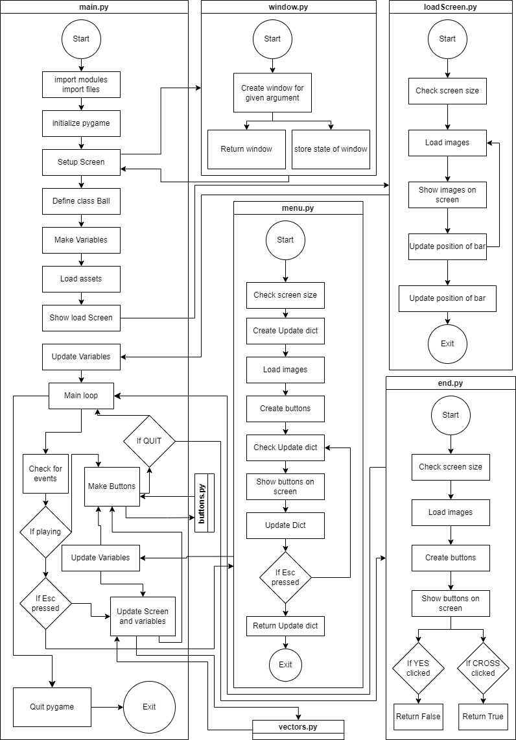 FLOWCHART  
Algorithms used

In main.py:

Collision Detection Algorithm: Detects collisions between balls and the ground, as well as between balls themselves.

Physics Simulation Algorithm: Simulates the motion of balls, considering gravity and elastic collisions.

Input Handling Algorithm: Handles keyboard inputs to control the balls and perform actions.

In menu.py:

Menu Rendering Algorithm: Renders the menu graphics on the screen.

Button Handling Algorithm: Detects button clicks and performs corresponding actions.

Menu Navigation Algorithm: Handles menu navigation and updates the active menu tab.

In loadScreen.py:

Loading Screen Rendering Algorithm: Displays loading screens and animations while the game is loading.

Animation Control Algorithm: Manages the timing and sequence of loading animations.

In vectors.py:

Vector Calculation Algorithm: Calculates and displays velocity vectors for the balls.

In window.py:

Window Initialization Algorithm: Initializes the game window and sets up the display.

Rendering Algorithm: Renders the game objects and graphics on the screen.

Display Update Algorithm: Updates the display to show changes in the game state.

Input Handling Algorithm: Handles keyboard inputs and events.

In buttons.py:

Button Creation Algorithm: Creates interactive buttons with specified properties.

Button Rendering Algorithm: Renders the buttons on the screen.

Button Click Detection Algorithm: Detects button clicks and triggers associated actions.

Input Handling Algorithm: Handles keyboard inputs and events on the end screen.

These algorithms work together to create the gravity simulation game, incorporating physics calculations, input handling, rendering, and user interaction.

Source codes: